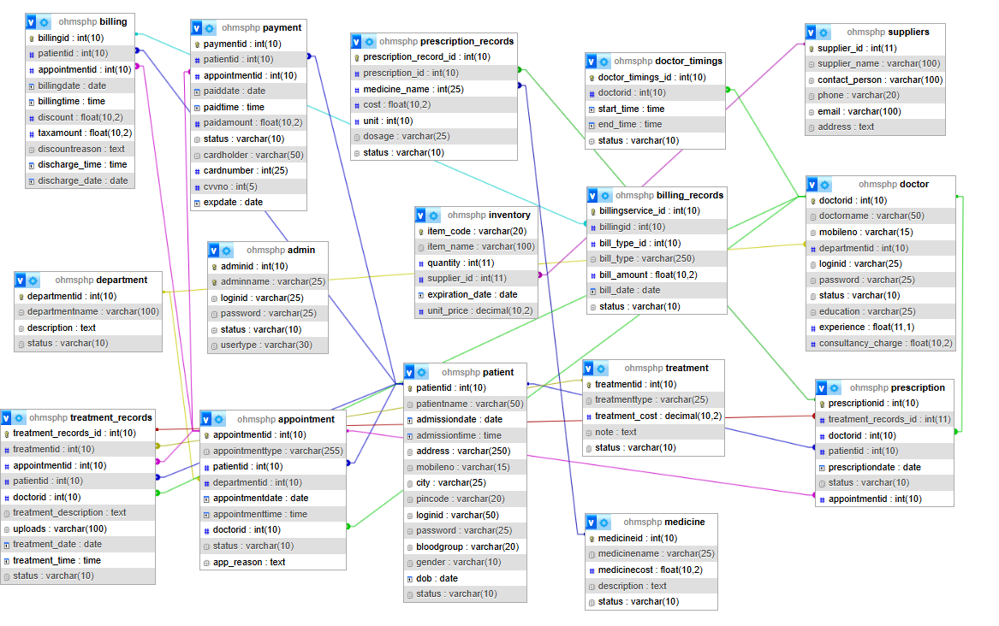

1. Show patient visit trends over the past 3 years by year, month, and department. Further break this data down by gender and age group.

SELECT

YEAR(v.visit_date) AS year,

MONTH(v.visit_date) AS month,

departmentname AS department,

p.gender,

CASE

WHEN TIMESTAMPDIFF(YEAR, p.dob, v.visit_date) < 18 THEN 'Child'

WHEN TIMESTAMPDIFF(YEAR, p.dob, v.visit_date) BETWEEN 18 AND 60 THEN 'Adult'

ELSE 'Senior'

END AS age_group,

COUNT(*) AS visits

FROM visits v

JOIN patient p ON v.patient_id = p.patientid

JOIN department d ON v.department_id = d.departmentid

WHERE v.visit_date >= DATE_SUB(CURDATE(), INTERVAL 3 YEAR)

GROUP BY year, month, department, gender, age_group

ORDER BY year, month, department;

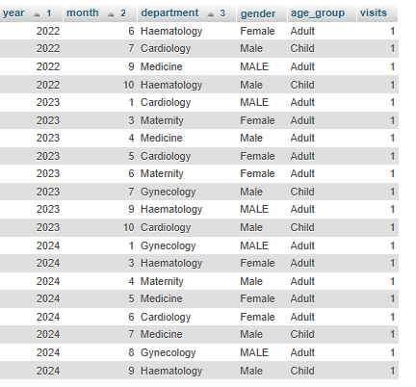

1. Identify medications supplied by a specific supplier that were used between two given dates, and list the patients who were prescribed those medications.

SELECT

DISTINCT p.patientid,

p.patientname,

pr.item_code,

m.medication_name,

pr.prescription_date

FROM

prescriptions pr

JOIN

medications m ON pr.item_code = m.item_code

JOIN

suppliers s ON m.supplier_id = s.supplier_id

JOIN

patient p ON pr.patient_id = p.patientid

WHERE

s.supplier_name = 'Specific Supplier Name' -- specify supplier here

AND pr.prescription_date BETWEEN '2024-01-01' AND '2024-05-01' -- specify date range here

ORDER BY

pr.prescription_date, p.patientname;

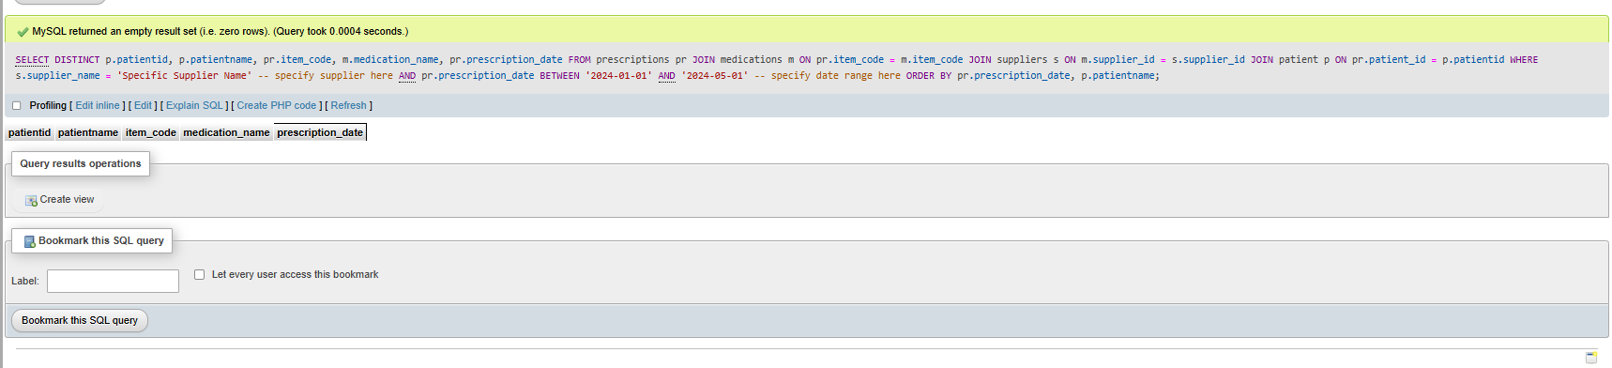

1. Find the top 2 departments by revenue generated in the past year.

SELECT

department_id,

SUM(amount) AS total_revenue

FROM

billing

GROUP BY

department_id

ORDER BY

total_revenue DESC;

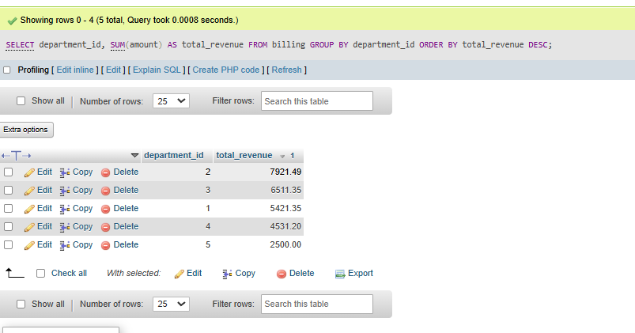

1. Find the top 2 doctors by number of patients seen in the past year.

SELECT

d.doctorname,

COUNT(DISTINCT v.patient_id) AS patients_seen

FROM

visits v

JOIN

doctor d ON v.doctor_id = d.doctorid

WHERE

v.visit_date >= DATE_SUB(CURDATE(), INTERVAL 5 YEAR)

GROUP BY

d.doctorname

LIMIT 2;

1. 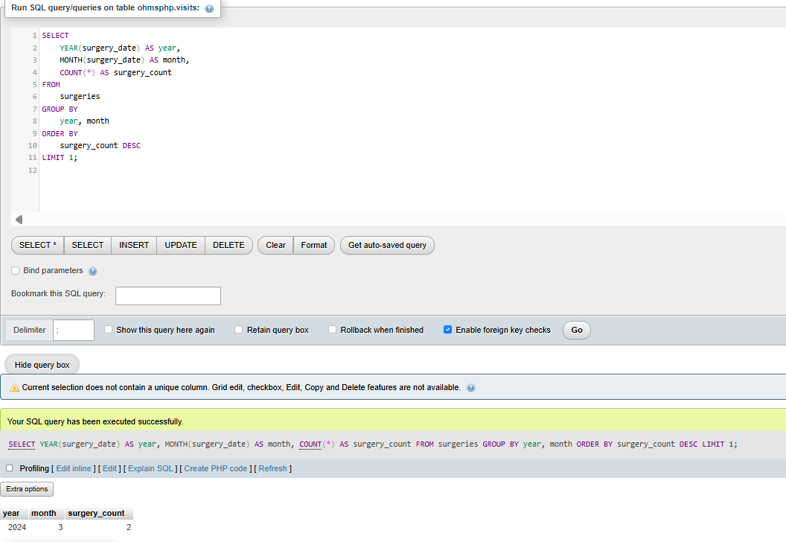In what months are the highest number of surgeries conducted?
2. Identify the supplier whose items stayed in inventory the longest on average.

